Test Case: tc003_SPX_Dev5_Crear_Requisicion_Spot_Tipo_Cobro_CC_Urgent
Step 1 - Enter username and password and click to button Enter : Credentials Entered
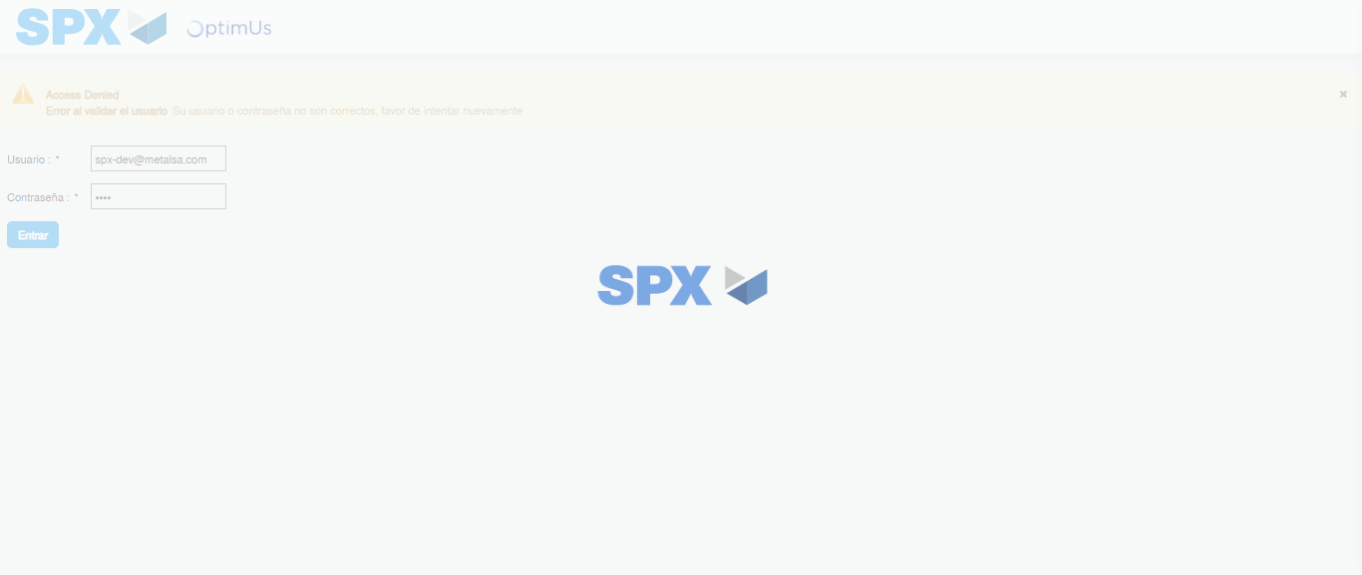Image file-name: QC_Testing-tc003_SPX_Dev5_Crear_Requisicion_Spot_Tipo_Cobro_CC_Urgent-1785959591448

Step 2 - Select to UEN and Access to Spot Buy Requisitions : UEN Correctly selected and Correct access
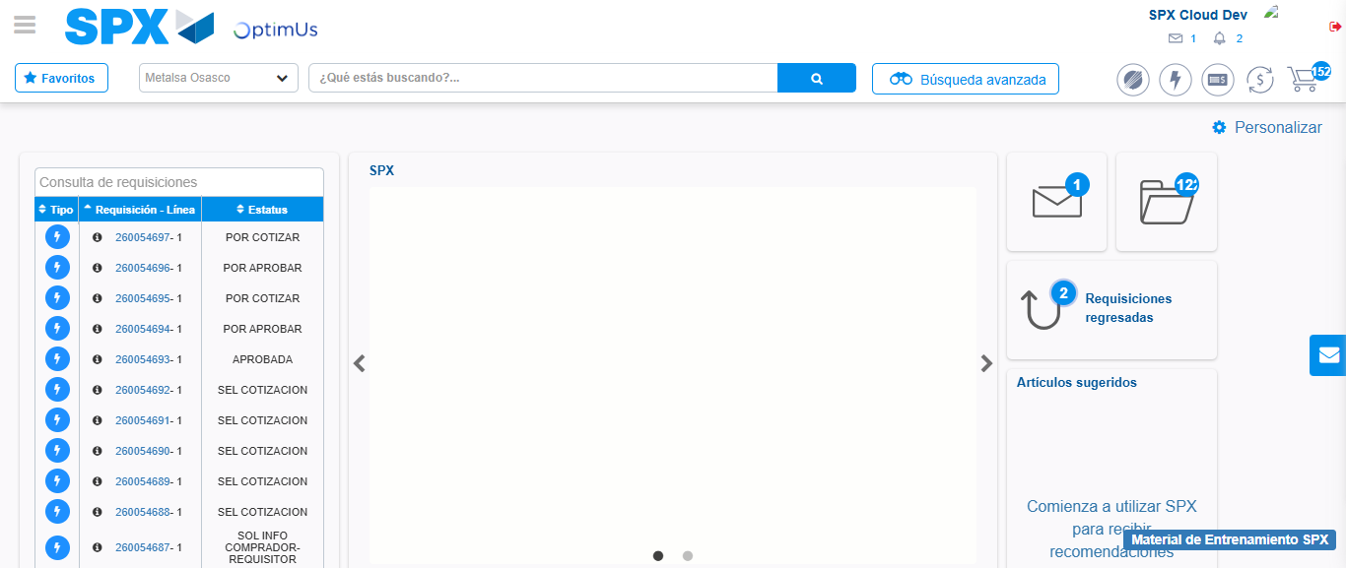Image file-name: QC_Testing-tc003_SPX_Dev5_Crear_Requisicion_Spot_Tipo_Cobro_CC_Urgent-1785959637513

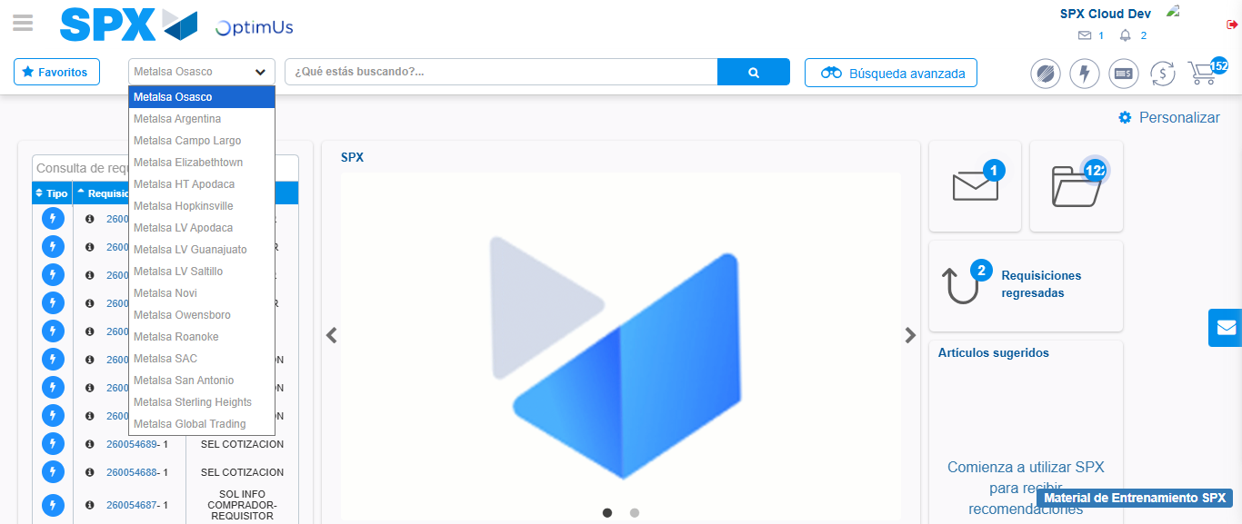Image file-name: QC_Testing-tc003_SPX_Dev5_Crear_Requisicion_Spot_Tipo_Cobro_CC_Urgent-1785959640099

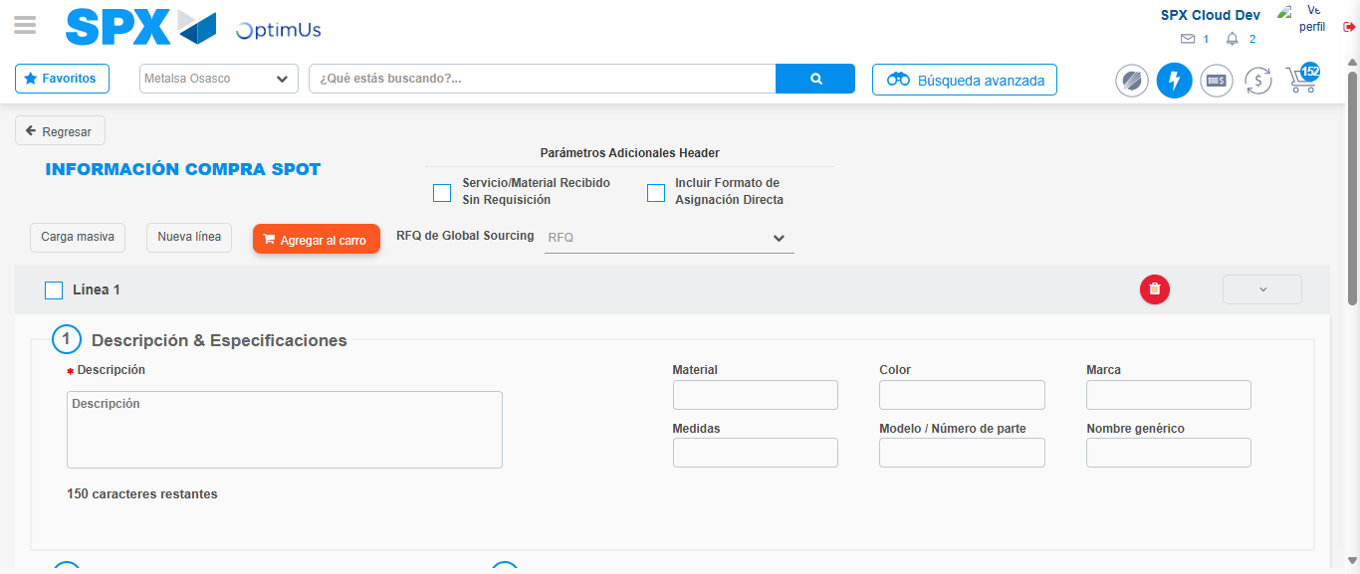Image file-name: QC_Testing-tc003_SPX_Dev5_Crear_Requisicion_Spot_Tipo_Cobro_CC_Urgent-1785959663034

Step 3 - Data Capture Spot Buy Requisition: Data captured correctly
Image file-name: QC_Testing-tc003_SPX_Dev5_Crear_Requisicion_Spot_Tipo_Cobro_CC_Urgent-1785959663300

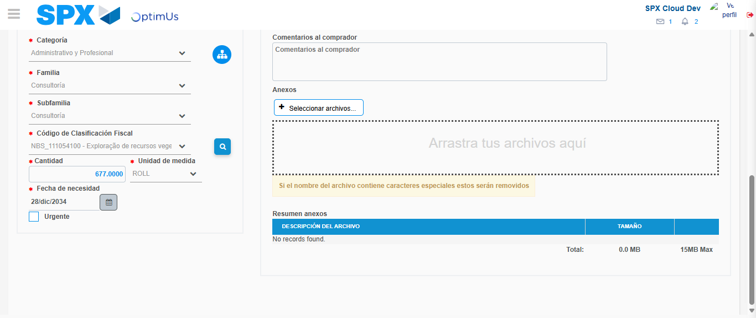Image file-name: QC_Testing-tc003_SPX_Dev5_Crear_Requisicion_Spot_Tipo_Cobro_CC_Urgent-1785959679342

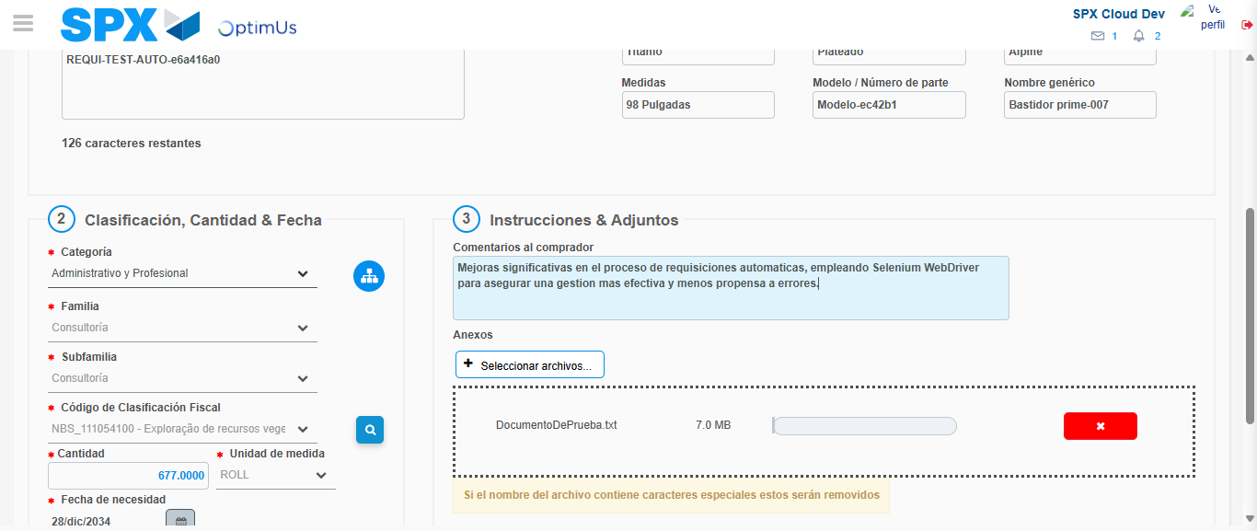Image file-name: QC_Testing-tc003_SPX_Dev5_Crear_Requisicion_Spot_Tipo_Cobro_CC_Urgent-1785959680151

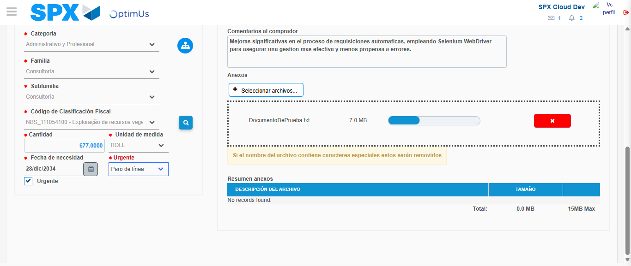Image file-name: QC_Testing-tc003_SPX_Dev5_Crear_Requisicion_Spot_Tipo_Cobro_CC_Urgent-1785959683856

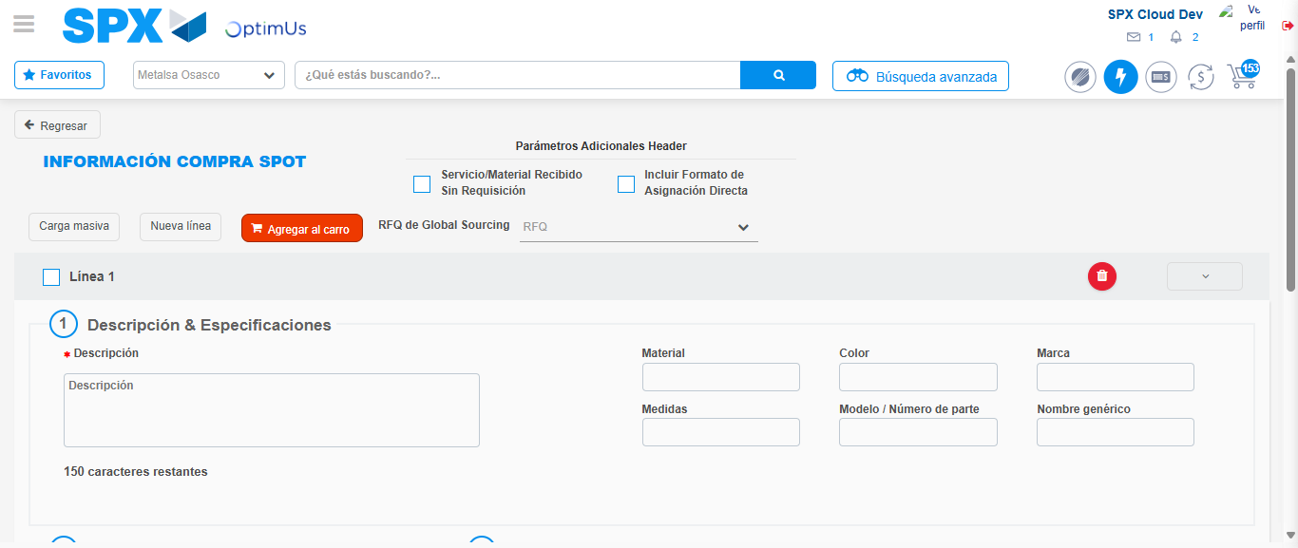Image file-name: QC_Testing-tc003_SPX_Dev5_Crear_Requisicion_Spot_Tipo_Cobro_CC_Urgent-1785959694902

Step 7 - Return to Main Page SPX : Return to Main Page SPX
Image file-name: QC_Testing-tc003_SPX_Dev5_Crear_Requisicion_Spot_Tipo_Cobro_CC_Urgent-1785959637513

Image file-name: QC_Testing-tc003_SPX_Dev5_Crear_Requisicion_Spot_Tipo_Cobro_CC_Urgent-1785959640099

Image file-name: QC_Testing-tc003_SPX_Dev5_Crear_Requisicion_Spot_Tipo_Cobro_CC_Urgent-1785959663034

Image file-name: QC_Testing-tc003_SPX_Dev5_Crear_Requisicion_Spot_Tipo_Cobro_CC_Urgent-1785959697127

Image file-name: QC_Testing-tc003_SPX_Dev5_Crear_Requisicion_Spot_Tipo_Cobro_CC_Urgent-1785959697283

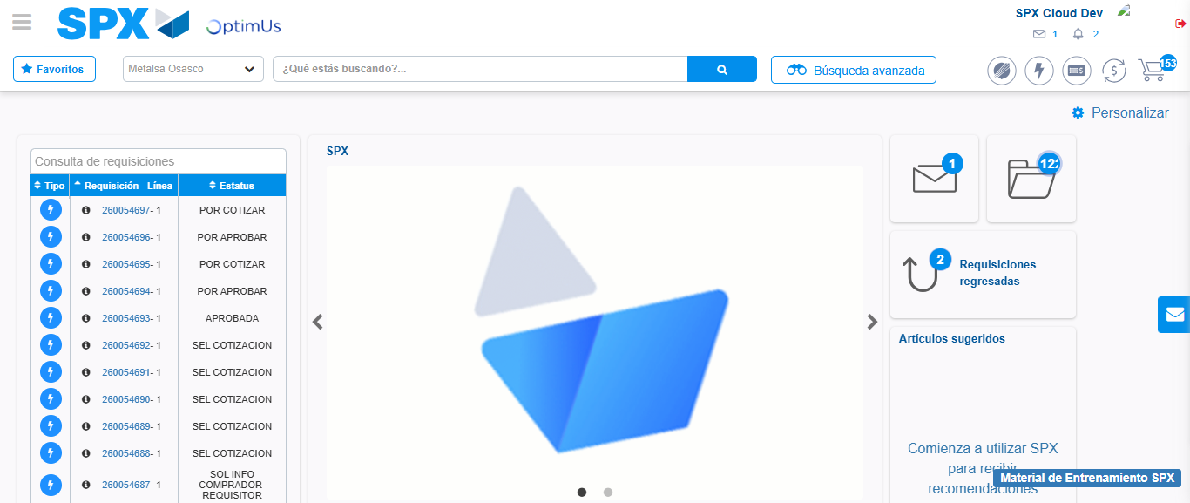Image file-name: QC_Testing-tc003_SPX_Dev5_Crear_Requisicion_Spot_Tipo_Cobro_CC_Urgent-1785959718523

Step 8 - Log Out : Log Out SPX
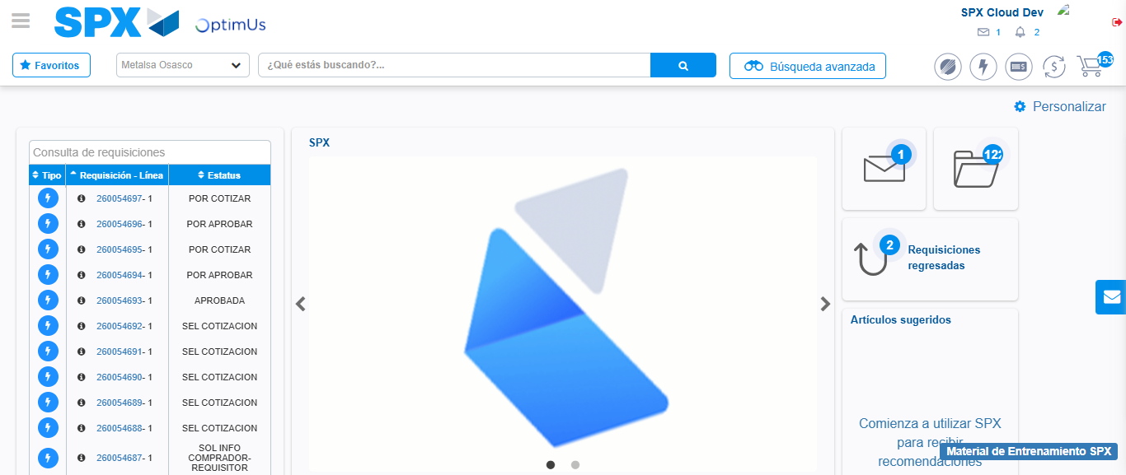Image file-name: QC_Testing-tc003_SPX_Dev5_Crear_Requisicion_Spot_Tipo_Cobro_CC_Urgent-1785959718827

